Planning and Environment Act 1987

SOUTH GIPPSLAND PLANNING SCHEME

AMENDMENT C109
PLANNING PERMIT application 2016/180

EXPLANATORY REPORT

Who is the planning authority?
The Amendment has been prepared by the South Gippsland Shire Council which is the planning authority for this amendment.
The Amendment has been made at the request of the owner of the subject land.

Land affected by the Amendment
The Amendment applies to land which is the site of the Venus Bay Caravan Park and a lot at 143B Inlet View Road, Venus Bay.
The site has a total area of approximately 12 hectares and includes four titles comprising Lot 2 PS 648056H, Lot 1 TP 172550M, Lot 1 PS 648056H and Res 1 PS 54175 as shown on Map 1.
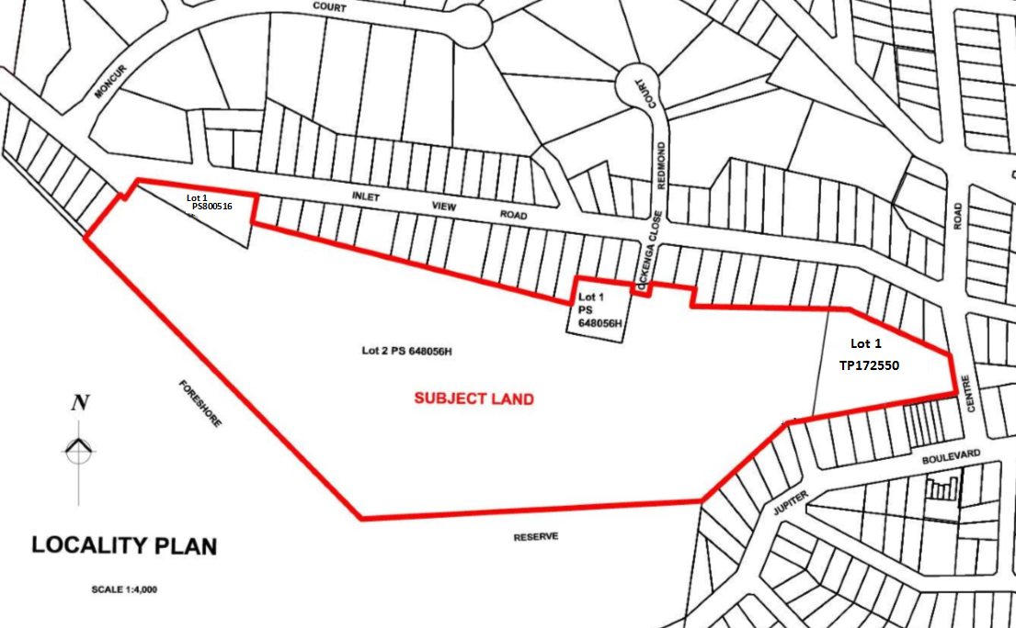

Map 1 – Subject Land

The eastern half of the site is currently used for the purpose of a caravan park and is adjacent to the existing commercial centre of Venus Bay to the east, and residential to the north, south east and west. Directly to the south of the site is the Cape Liptrap Coastal Park with the southernmost tip of the site being only 425 metres from the coastal foreshore. The site is predominately vegetated with remnant native vegetation including but not limited to Coastal Banksia, Coastal Tea-Tree, Coastal Wattle, Coastal Beard-heath and Sea-berry Saltbush.

What the amendment does
The Amendment proposes to introduce new planning controls to the site to protect its ongoing use as a caravan park and to allow for low density residential development on land identified as surplus to the caravan parks’ current and future needs. The Amendment also seeks to create an additional two Township Zone lots which are surplus to the needs of the caravan park. The lot containing the caravan park will be zoned Special Use Zone.
Specifically, the Amendment:
- Rezones a portion of Lot 2 PS648056H from the Farming Zone (FZ) to the Special Use Zone Schedule 7 (SUZ7).
- Inserts a new Schedule to the SUZ in Clause 37.01 in the form of Schedule 7.
- Rezones a portion of Lot 2 PS648056H from the FZ to the Low Density Residential Zone (LDRZ).
- Rezones Llot 1 PS648056H from the FZ to the LDRZ.
- Rezones a portion of Lot 1 TP 172550M from the FZ to the Township Zone (TZ).
- Rezones a portion of Lot 1 TP 172550M from the FZ to the SUZ7.
- Rezones Lot 1 PS 54175 from the TZ to the LDRZ.
- Rezones Ockenga Close and the road leading to the caravan park off Jupiter Boulevard from the FZ to the TZ.
- Amends Planning Scheme Map 24ESO3 by deleting the Environmental Significance Overlay Schedule 3 from the land to be rezoned to the LDRZ and TZ.
- Amends Planning Scheme Map 24DDO by including the land to be rezoned to the LDRZ and TZ in the Design and Development Overlay Schedule 5.
- Amends Planning Scheme Map 24ESO7 by including the land to be rezoned to the LDRZ and TZ in the Environmental Significance Overlay Schedule 7.

The planning permit application seeks approval for the subdivision of the land into nine lots and the removal of native vegetation.
Specifically, the planning permit includes:
- A six lot subdivision of land to be rezoned to the LDRZ (known as Lots 1-6 on the proposed plan of subdivision)
- A two lot subdivision of land to be rezoned to the TZ (known as lots 7-8 on the proposed plan of subdivision)
- A single lot created for the balance of the land to be rezoned to the SUZ7 (known as lot 9 on the proposed plan of subdivision).
The proposed Plan of Subdivision is shown in Map 2. The planning permit is attached as a separate document to this Explanatory Report. A zoning map can be found below at Map 3.
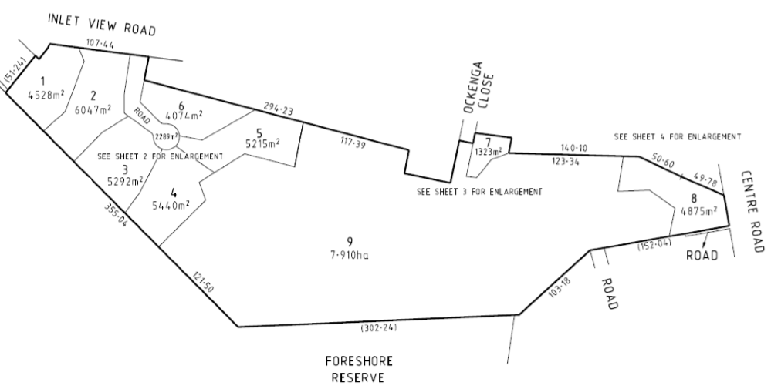
Map 2 – Proposed Plan of Subdivision
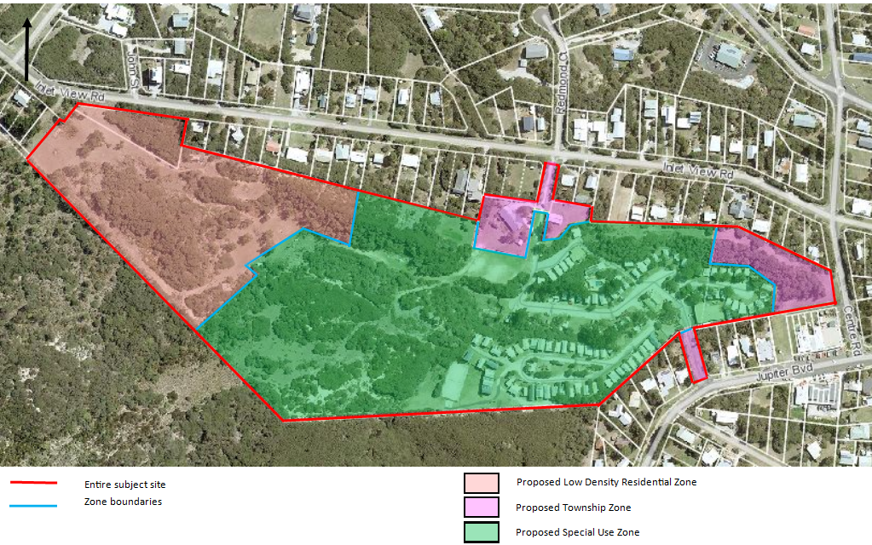

Map 3– Proposed zoning map

Strategic assessment of the Amendment

Why is the Amendment required?

Council has been approached by the owners of the Venus Bay Caravan Park to rezone and subdivide their land to help facilitate the ongoing use of the land as a caravan park by subdividing off surplus land and placing the Venus Bay Caravan Park in a SUZ to encourage the ongoing use of the land as a caravan park.

Caravan parks are an affordable tourist accommodation option for visitors to rural and regional Victoria. In smaller communities, caravan parks often form an important part of the local economy and community. They are also important to help accommodate the surge in temporary resident and visitor numbers during key holiday periods.

Coastal caravan parks in private ownership are attractive to developers wishing to develop in coastal townships. Councils have limited control over private business and cannot require them to stay in operation. Therefore, where opportunities arise to protect the kind of asset which provides a net benefit to the community, the protection of the ongoing use can be encouraged through the application of appropriate land use controls in the planning scheme.

Proposed Special Use Zone Schedule 7 (SUZ7)

The proposed SUZ7 provides certainty for the caravan park and allows for certain ancillary uses to occur with a planning permit such as a backpackers lodge and hostel. The SUZ7 sets out the notification (advertising of permit applications) requirements for certain subdivision and developments within the zone. Subdivision is exempt from the notice requirements except where a subdivision creates more than two lots and subdivision increases the number of lots adjoining residential zoned lots adjoining the Special Use Zone. An application for buildings and works is exempt from the notice requirements except where buildings and works are located 10 metres or less from the external boundary of the Special Use Zone. Use of the land is not exempt from the notice requirements.

Proposed Low Density Residential Zone

The area west of the Venus Bay Caravan Park is identified on the Venus Bay Framework Plan as 'Potential Long Term Urban Expansion Investigation Area'. The land is currently zoned Farming Zone which does not facilitate residential development or subdivision. Due to the size of the Farming Zone land that is surplus to the Venus Bay Caravan Park and the strategic direction of the Framework Plan, it is considered appropriate to place a residential zone in this area.

Due to environmental constraints such as soil capability, bushfire risk considerations and native vegetation, it is considered a Low Density Residential Zone would be appropriate as this zone facilitates larger residential lots. The rezoning of this area as Low Density Residential Zone does not restrict the ongoing use of the remainder of the land for a caravan park.

How does the Amendment implement the objectives of planning in Victoria?
The proposed amendment implements the objectives set out in Section 4 of the Planning and Environment Act 1987 (the Act).
The objectives of planning in Victoria are:
a) To provide for the fair, orderly, economic and sustainable use and development of land.
b) To provide for the protection of natural and man-made resources and the maintenance of ecological processes and genetic diversity.
c) To secure a pleasant, efficient and safe working, living and recreational environment for all Victorians and visitors to Victoria.
d) To conserve and enhance those buildings, areas or other places which are of scientific, aesthetic, architectural or historical interest, or otherwise of special cultural value.
e) To protect public utilities and other assets and enable the orderly provision and coordination of public utilities and other facilities for the benefit of the community.
f) To facilitate development in accordance with the objectives set out in the points above.
g) To balance the present and future interests of all Victorians.
The proposed rezoning addresses multiple objectives of the Act. The proposal seeks to ensure the low density residential subdivision component is carefully considered to ensure it is consistent with the orderly planning of the area. The proposal will assist the ongoing use of part of the land for a caravan park through the application of a Special Use Zone specifically tailored for this site.

How does the Amendment address any environmental, social and economic effects?
Environmental
Land Capability
Land Capability Assessments have been submitted for all the proposed lots subject to this proposal.
The following conclusions can be made from the Land Capability Assessments:
• Adequate land area is available for sustainable long term land application of wastewater from residential dwellings, given the proposed rezoning.
• Enactment of the requirements of the report in the subdivision planning permit and the waste-water permit conditions will address likely human and environmental health risks associated with effluent disposal over the subject land
Native Vegetation
A Flora and Fauna Assessment has been undertaken to determine the effect the proposal will have on flora within the subject site. The site is predominantly remnant native vegetation and is part of the Coast Banksia Woodland Ecological Vegetation Class. The dominant vegetation found onsite is Coast Tea-tree, Coast Wattle, Coast Beard-heath, Sea-berry Saltbush and introduced Panic Veldt-grass with scattered Coast Banksia as canopy trees.
Subdivision and development of the land is expected to result in the removal of approximately 0.234 hectares of native vegetation from remnant patches and 2 scattered trees (equating 0.140hectares) from the subject site.
Fauna
A Flora and Fauna Assessment has been undertaken to determine the effect the proposal will have on fauna within the subject site. A number of fauna species was identified as potentially being affected; however site visits confirmed that only a minor number of fauna may be affected. It has been identified the following fauna may be susceptible as a result of the proposal:
- Common Wombat;
- Black Wallaby;
- Eastern Grey Kangaroo;
- White-bellied Sea-Eagle;
- Fork-tailed Swift;
- White-throated Needletail;
- Rufous Fantail;
- Yellow-bellied Sheathtail Bat.
The assessment concludes that while these fauna may utilise the study area, it is unlikely that the development of the low density subdivision will pose a direct threat to both habitat and species.
Social
Cultural Heritage
Consideration has been given to whether the proposed rezoning and subsequent subdivision will impact on any cultural heritage in the area. A due diligence cultural heritage assessment has been undertaken and while there are registered cultural heritage site near the subject site, none are located on the property. These cultural heritage sites include shell midden, human burial and earth features. The proposal will not cause detriment to these sites.
The site itself is not within an area of cultural sensitivity, and therefore no further assessment is warranted and a Cultural Heritage Management Plan is not required.
Developer Contributions
As part of the subdivision proposal for the Low Density Residential Zone subdivision, developer contributions will be required to be paid to Council per each residential lot created. This money will be used towards upgrading existing infrastructure or providing community infrastructure.
Economic
Economic effects of the proposed rezoning are expected to be positive. The development of the subdivision will provide opportunities for local businesses, both during construction and as a consequence of an increased population base, which are both positive economic outcomes.

Does the Amendment address relevant bushfire risk?
The site is entirely contained within the Bushfire Management Overlay and is within a Bushfire Prone Area under the building regulations. The proposal has addressed bushfire risk by undertaking a Bushfire Management Statement to accompany the subdivision component. Future development will be conditioned to require that all the new lots will have a Bushfire Attack Level (BAL) of between BAL12.5 and BAL29.
The Amendment is supported by a Bushfire Planning Considerations Report prepared by bushfire consultants Euca Planning Pty Ltd. This report has considered advice from the Country Fire Authority (CFA), the Victorian Fire Risk Register, the Regional Bushfire Planning Assessment and the South Gippsland Fire Management Plan. It has also considered the relevant planning policies within the South Gippsland Planning Scheme.

Does the Amendment comply with the requirements of any Minister’s Direction applicable to the amendment?
The Amendment complies with the Ministerial Direction on the Form and Content of Planning Schemes under Section 7(5) of the Act and the Ministerial Directions issued under Section 12(2) (a) of the Act. The explanatory report has evaluated and discussed the relevant strategic considerations as outlined in Minster’s Direction 11 Strategic Assessment of Amendments.

How does the Amendment support or implement the State Planning Policy Framework and any adopted State policy?

Clause 11 Settlement

Clause 11.02-1 Supply of Urban land

Objective:

To ensure a sufficient supply of land is available for residential, commercial, retail, industrial, recreational, institutional and other community uses.

Strategy:

Restrict low-density rural residential development that would compromise future development at higher densities.

As this property abuts the Cape Liptrap Coastal Park, a lower residential density should be considered here due to environmental considerations. Higher densities can be accommodated in the existing residential areas of Venus Bay.

Clause 11.05-5 – Coastal Settlement

Objective:

To plan for sustainable coastal development.

Strategy:

Support a network of diverse coastal settlements which provides for a broad range of housing types, economic opportunities and services.

The proposal will ensure that the caravan park will continue to operate as an affordable holiday option. The rezoning of the land to a Special Use Zone will help with the continual use of the land for a tourist destination which will continue to provide economic benefits to the township. This is further supported by the Strategy which identifies Venus Bay as having tourist opportunities in the municipality due to the role, location, amenity and environmental values of Venus Bay.

Clause 12 – Environmental and Landscape Values

Clause 12.01-1 Protection of biodiversity

Objective:

To assist the protection and conservation of Victoria’s biodiversity, including important habitat for Victoria’s flora and fauna and other strategically valuable biodiversity sites.

Strategy:

Consider the impacts of any change in land-use or development that may affect the biodiversity value…and sites utilised by species designated under the Japan-Australia Migratory Birds Agreement (JAMBA) or the China-Australia Migratory Birds Agreement (CAMBA).

The Flora and Fauna Assessment provided has identified that the following migratory birds have potential to occur on the site:

Fork-tailed Swift (protected under JAMBA and CAMBA). The report identifies that there is a potential for these birds to use the site for foraging however none have been recorded as being present on the site.

White-throated Needletail (protected under JAMBA and CAMBA). The report identifies that these birds are likely to occur to seasonally forage.

While the report identifies that two protected migratory bird species have potential to forage the site, the proposal does not propose to remove significant amounts of native vegetation. Additionally, they have not been identified as likely nesting sites which would not affect the nesting habitat of these species. As such, it is determined that the JAMBA and CAMBA agreements have not been breached by the proposed development.

Clause 12.02-2 Appropriate development of coastal areas

Objective:

To ensure development conserves, protects and seeks to enhance coastal biodiversity and ecological values

The proposal to rezone part of the land to a Special Use Zone will help facilitate the ongoing use of the land for a caravan park into the foreseeable future. This means it is unlikely the land will be brought with the intention to develop it for more intensive residential purposes which could result in the loss of substantial native vegetation. Additionally, the low density residential component of the proposal will allow large allotments which will allow some retention of native vegetation.

Clause 12.02-4 Coastal tourism

Objective:

To encourage suitably located and designed coastal and marine tourism opportunities.

Strategy:

Ensure that a diverse range of accommodation options and coastal experience are maintained and provided for and that sites and facilities are accessible to all.

The rezoning of the land occupied by the caravan park to a Special Use Zone will ensure that an affordable accommodation option is available for visitors to the region. The caravan park is within close proximity to the Cape Liptrap Coastal Park and an hour’s drive to Wilsons Promontory National Park. Therefore, by facilitating an affordable accommodation option, ensures that a wide variety of people can visit the region.

Clause 21.04-1 Environmentally sensitive areas

Objective:

To protect and conserve environmentally sensitive areas

Strategy:

Protect environmentally sensitive areas with significant recreational value such as the Dandenong and Macedon Ranges, the Upper Yarra Valley, Western Port and Port Phillip Bays and their foreshores, the Mornington Peninsula, the Yarra and Maribyrnong Rivers and the Merri Creek, the Grampians, the Gippsland Lakes and its foreshore, the coastal areas and their foreshores and the Alpine areas as well as nominated urban conservation areas, historic buildings and precincts from development which would diminish their environmental conservation or recreation values.

The proposal to rezone part of the land for the caravan park is considered to enhance recreational values as it will protect and ensure the ongoing use of the land for a caravan park in this coastal settlement.

Clause 13 – Environmental Risk

Clause 13.05-1 Bushfire planning strategies and principles

Objective:

To assist to strengthen community resilience to bushfire

Strategies:

Overarching strategies

Prioritise the protection of human life over other policy considerations in planning and decision-making in areas at risk from bushfire.

Where appropriate, apply the precautionary principle to planning and decision making when assessing the risk to life, property and community infrastructure from bushfire.

In addition to the overarching strategies, the following are subheading strategies which must be considered:

Bushfire hazard identification and risk assessment strategies;

Strategic and settlement planning strategies;

Planning scheme implementation strategies; and

Development control strategies.

The proposal has responded to the risk of bushfire through both supplying a Bushfire Context Report from Euca Planning Pty Ltd for the rezoning consideration and a Bushfire Management Statement for the subdivision component of the proposal. Both of these documents set out the required development requirements to ensure any new dwellings constructed can be adequately defended in the event of a bushfire.

Clause 14 Natural Resource Management

Clause 14.01-1 Protection of agricultural land

Objective:

To protect productive farmland which is of strategic significance in the local or regional context.

Strategies:

Ensure that the State’s agricultural base is protected from the unplanned loss of productive agricultural land due to permanent changes of land use.

Permanent removal of productive agricultural land from the State's agricultural base must not be undertaken without consideration of its economic importance for the agricultural production and processing sectors.

The removal of agricultural land is considered appropriate in this instance and will not affect the agricultural production and processing sectors. The land is currently used for grazing purposes and is not intensively farmed. The current predominant land use is the caravan park.

Clause 16 Housing

Clause 16.02-1 Rural residential development

Objective:

To identify land suitable for rural living and rural residential development.

Strategies:

Ensure land is only zoned for rural living or rural residential development where it:

Is located close to existing towns and urban centres, but not in areas that will be required for fully serviced urban development.

Can be supplied with electricity and water and good quality roads.

The property is located on the periphery of the Venus Bay settlement boundary but is identified by the Venus Bay Estate 1 Framework Plan as potential long term residential (see Map 3).

Clause 17 Economic Development

Clause 17.03-1 Facilitating Tourism

Objective:

To encourage tourism development to maximise the employment and long-term economic, social and cultural benefits of developing the State as a competitive domestic and international tourist destination.

The application of the Special Use Zone to the caravan park will encourage the ongoing operations of this business in Venus Bay and will continue to facilitate the tourism industry in the southern portion of the Shire.

How does the Amendment support or implement the Local Planning Policy Framework, and specifically the Municipal Strategic Statement?

Clause 21.04 Vision

Clause 21.04 Vision – South Gippsland Shire Council – Council Plan 2010-2014

The South Gippsland Shire Council – Council Plan sets out the key future directions of the Council. The mission of the Plan is “To effectively plan and provide for the social, built, economic and natural environments that ensure the future wellbeing of South Gippsland communities”. The Municipal Strategic Statement is consistent with and enhances the vision of the Council Plan.

Applicable visions are:

Settlement

Availability of high quality and diverse lifestyle opportunities;

The coastal environment is protected for its environmental, recreational, cultural, economic, heritage and landscape values;

Development in bushfire prone areas is compatible with the bushfire risk.

Economic Development

The thriving tourism industry builds on the Shire’s coastline, environmental qualities, heritage assets, rural landscape and agricultural produce.

Clause 21.05 Settlement

Towns – roles and functions – Venus Bay

Venus Bay is described under this clause as a small coastal village that supports a small permanent population and is an attractive holiday destination. Venus Bay provides convenience facilities and is reliant on Tarwin Lower and Leongatha for major retail, industrial and commercial facilities.

Objective:

To ensure the growth of towns occurs in accordance with their role and function

Strategy:

Promote the residential use and development of land in accordance with the township framework and structure plans at Clause 21.15.

Clause 21.06 Environmental and landscape values

Clause 21.06-2 Coastal and hinterland landscapes

Objective:

To ensure that coastal development at the edge of settlements responds appropriately to the landscape setting and character.

The residential component of the development is at a significantly lower density to lots immediately abutting the site in the township. The residential development component will be of similar density to an existing low density estate immediately across the road to the north of the subject site.

Clause 21.15 Local Areas

Clause 21.15-9 Local Areas – Venus Bay

Settlement:

This clause states limit projected residential growth to the long term development areas identified on the Venus Bay Framework Plan (see Map 4 below). The proposal is consistent with the long term vision for Venus Bay. However, not all of the area identified as long term residential on the Framework Plan will be rezoned low density residential and some will be retained for the purpose of the caravan park.

This provision also sets out prerequisites that are required to be met prior to any expansion into the long term growth area. This includes:

A significant proportion of vacant lots within the Township Zone and Low Density Residential Zone have been developed;

Reticulated water and sewerage is available;

Further investigation is undertaken to confirm the extent of potential problems associated with acid sulfate soils and flooding;

Further investigation is undertaken to confirm the location of sites of recognised cultural and heritage significance; and

Further investigation is undertaken to confirm the location of sites of recognised environmental significance.

The Housing and Settlement Strategy identifies that there are around 70 vacant low density lots in the Shire and that low density is the preferred zone over rural living. In Venus Bay, there are currently five vacant lots in the low density area. The Low Density Residential Zone does not require connection to reticulated sewerage.

Due to the soil structure (predominantly sand) in this particular area of Venus Bay, it is unlikely that acid sulphate soils will be present on the subject land. The proponent has undertaken both a Cultural Heritage Study and a Flora and Fauna Study to establish whether the proposal will have effects on recognised sites of cultural significance and sites of environmental significance. This is discussed above further within this report.

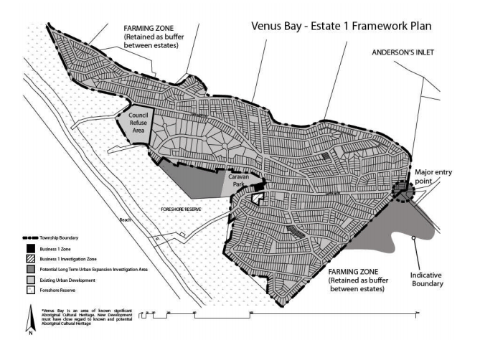

Map 4 – Venus Bay Estate 1 Framework Plan

Does the Amendment make proper use of the Victoria Planning Provisions?
The Amendment makes proper use of Clause 37.01 Special Use Zone as the complexity of the planning requirements means that other zones, overlays or local policies cannot give effect to the desired objectives or requirements.
Public Exhibition and Appeal Rights in the Special Use Zone
It is important to note that the proposed SUZ7 includes an exemption from the public notification and appeal rights (the process of appealing a Council decision to the Victorian Civil and Administrative Tribunal – VCAT) for planning permit applications for buildings and works except where the buildings and works are within 10 metres or less from the boundary of the Special Use Zone. This means that if buildings and works require a planning permit and the location of the buildings and works is 15 meters from adjoining land not in the Special Use Zone, the adjoining landowners will not be notified and cannot appeal Council’s decision to VCAT. The SUZ7 provides no exemptions for planning permit applications for the use of the land and Council can advertise use applications and objectors can still appeal use applications to VCAT as per the normal process.

How does the Amendment address the views of any relevant agency?

Servicing agencies / authorities with an interest in the subdivision of land (including the CFA) have provided conditions for the planning permit to enable exhibition of Permit 2016/180.

Does the Amendment address relevant requirements of the Transport Integration Act 2010?
The Amendment has no impact on the transport system or the Transport Integration Act 2010.

Resource and administrative costs

What impact will the new planning provisions have on the resource and administrative costs of the responsible authority?
The Amendment and Planning Permit costs, including Panel fees if required, will be met be by the proponent.

Where you may inspect this Amendment
The Amendment is available for public inspection, free of charge, during office hours at the following places:
- South Gippsland Shire Council Main Office – 9 Smith Street Leongatha
- South Gippsland Shire Council web page www.southgippsland.vic.gov.au/C109
- The Amendment can also be inspected free of charge at the Department of Environment, Land, Water and Planning website at www.delwp.vic.gov.au/public-inspection.

Submissions
Any person who may be affected by the Amendment [and/or planning permit] may make a submission to the planning authority. Submissions about the Amendment and planning permit must be received by Monday 31 July 2017.
A submission must be sent to: South Gippsland Shire Council, Ken Griffiths, Strategic Planning Coordinator, Private Bag 4, Leongatha Victoria 3953 or email council@southgippsland.vic.gov.au with “Submission to Amendment C109” in the subject line.

Panel hearing dates
In accordance with Clause 4(2) of Ministerial Direction No.15 the following panel hearing dates have been set for this amendment:
- directions hearing: week commencing 9 October 2017
- panel hearing: week commencing 30 October 2017

