21.15-9 Venus Bay
Future population growth in Venus Bay, when required, will be promoted within the existing zoned land and in the growth areas defined on the Venus Bay Framework Plan. It will provide low end convenience facilities and rely on Tarwin Lower and Leongatha for access to major retail, industrial and commercial facilities. Simple urban forms, low rise development and the natural bushland setting will continue to characterise the appearance of the village.
13/06/2014

Proposed C109

Local area implementation
- Ensure that any proposed use and development of land in Venus Bay is generally in accordance with the Venus Bay Estate 1 and Estate 2 Framework Plans
Settlement
- Discourage development in areas susceptible to erosion
- Maintain the current housing density
- Limit projected residential growth to the long term development areas identified on the Venus Bay Framework Plan
- Encourage the ongoing use and development of the Special Use Zone for the purpose of a caravan park.
- Discourage uses in the Special Use Zone which compromise the purpose of the zone.
- Ensure that any expansion into the long term development areas identified on the Venus Bay Framework Plan does not occur until the following Development Prerequisites have been met:
- a significant proportion of vacant lots within the Township Zone and Low Density Residential Zone have been developed
- reticulated water and sewerage is available
- further investigation is undertaken to confirm the extent of potential problems associated with acid sulfate soils and flooding
- further investigation is undertaken to confirm the location of sites of recognised cultural and heritage significance
- further investigation is undertaken to confirm the location of sites of recognised environmental significance
Environment
- Ensure that each site is capable of on-site waste disposal that does not prejudice groundwater quality
- Maintain areas of indigenous and native vegetation where possible in new development
- Protect the environmental values of Anderson Inlet and Cape Liptrap Coastal Park
Landscape and built form
- Maintain the low key holiday character of the village and preserve the different styles of each estate
- Maintain the rural buffer between the first, second and third estates of Venus Bay as well as between Venus Bay and Tarwin Lower
- Encourage the use of best practice water sensitive urban design measures for new developments
- Promote ecologically sustainable and attractive forms of development that complement the natural environmental characteristics of Venus Bay
Further strategic work
- Investigate a flood study for Venus Bay to inform a local policy or overlay control within the planning scheme. The study should include a reference to climate change impacts
- Review the suitability of planning controls to land potentially affected by flooding, acid sulfate soils and sites of known cultural heritage significance. Amend or develop new controls as appropriate
- Develop a Master Plan, which clearly defines the boundaries of commercial development, and planning controls to ensure that the design of commercial areas is consistent with preferred town character
- Investigate rezoning land to the south of Jupiter Boulevard, Venus Bay, from Township Zone to Commercial 1 Zone as shown in the Venus Bay Framework Plan in order to focus the commercial use and development into a central precinct and reduce these uses amongst residential uses
- Investigate rezoning the Commercial 1 Zone land in Black Avenue in Venus Bay Estate 2 to Township Zone, in order to recognise and support the existing role of the commercial area in Venus Bay Estate 1
Reference documents
Venus Bay Urban Design Framework: Settlement Background Paper (2006)
Infrastructure Design Manual (version 4, March 2013) (as amended)
Healthy by Design 2012 (as amended)
South Gippsland Open Space Strategy 2007(as amended)
South Gippsland Recreation Plan 2007 (as amended)
The South Gippsland Housing and Settlement Strategy, 2013
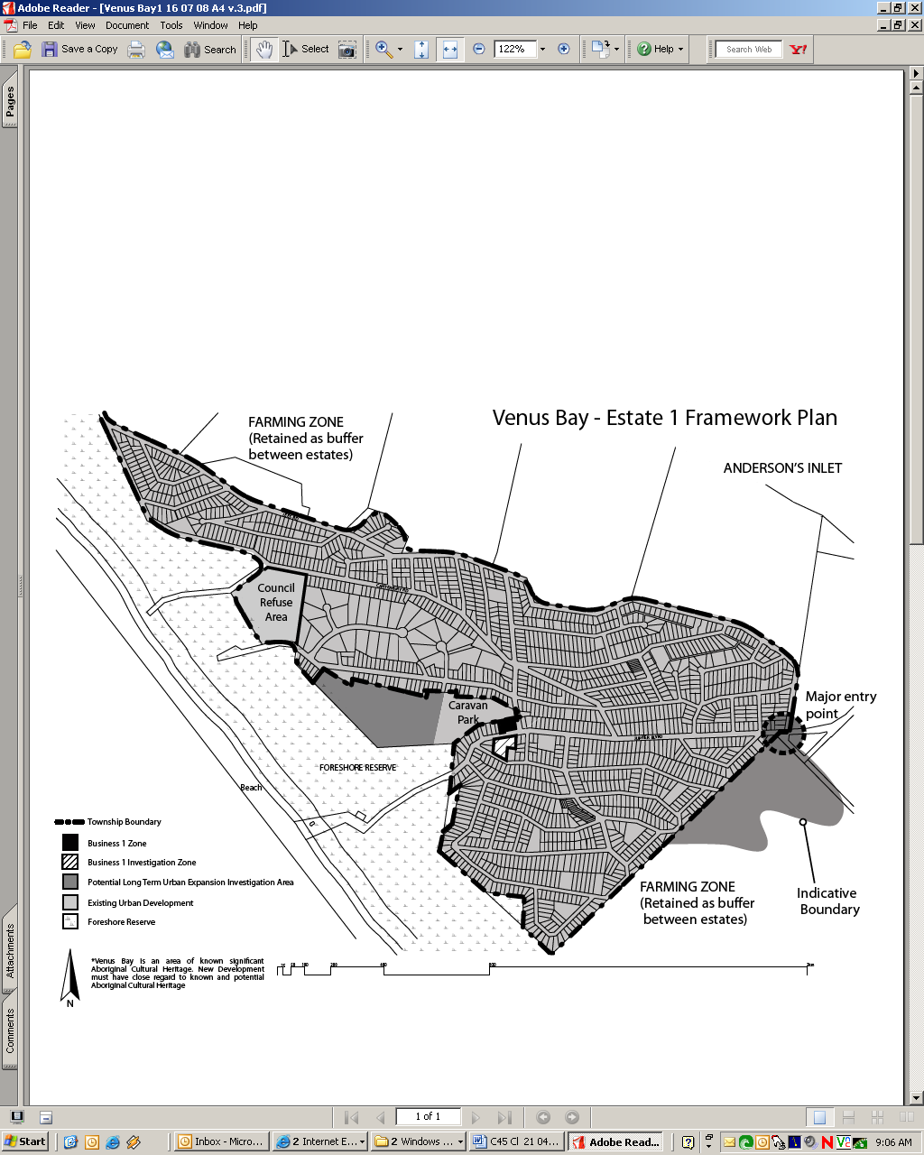
The South Gippsland Housing and Settlement Strategy, 2013

