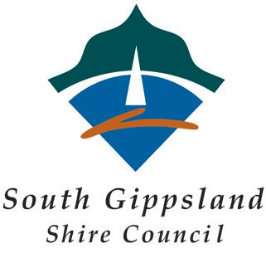

Mossvale Park Booking Form
Note: Please be aware that Mossvale Park is a public space and there are no exemptions to allow booking of the whole park. You cannot stop people from using the park for general use.

Name:

Phone Number:

Email:

Purpose of Event:

Type of Event: Commercial (market, event that makes profit) - $500 fee

Non Commercial (free community event, wedding, funeral, private function) - $0

Number of Guests:

Date of Event

Time of Event Start time (including set up) 12pm

End time 8pm

Power Required: YES / NO Commercial $100 fee
(Circle One)
YES / NO Non-commercial - $50 fee

Other YES / NO Parking Area behind Soundshell (Commercial) - $200 Fee
(Circle One)
YES /NO Parking Area behind Soundshell (Non-commercial) - $100 fee

YES / NO Soundshell – Sides Down (Commercial) - $100

YES / NO Soundshell – Sides Down (Non-Commercial) - $50

All fees paid contribute to park maintenance and programs.

For some activities, additional conditions may be required. Please note the following conditions for your event. Submitting your booking is acceptance of these conditions.

Security – The requirement to provide security will depend on type of event and numbers expected. This may not apply to your event. You will be advised if Security is required after your booking request is received.

- You are required to provide professional crowd control / security for your event. Evidence of this must be provided at least one week prior to your event, or the booking will be cancelled.
- You are required to register your event with PartySafe or your local Police Station. Evidence of this registration must be provided at least one week prior to your event, or the booking will be cancelled. www.police.vic.gov.au/party-safe

Alcohol

General Local Law 2014 provides for alcohol in public space as follows;

21. Liquor

(1) A person must not, without a permit -
(a) Consume any liquor on a road; or
(b) Consume any liquor in any other public place between 10:00pm and sunrise; or
(c) Have in his or her possession or control any liquor other than liquor in a sealed container on a road or any other public place between 10:00pm and sunrise.

Any activity in public space that includes service of alcohol / and or BYO alcohol outside these hours must be licensed through Victorian Commission for Gambling and Liquor Regulation (Temporary Limited License). This can take up to six weeks for the commission to approve / reject.

Victorian Commission for Gambling and Liquor Regulation - https://www.vcglr.vic.gov.au/

Damage

An inspection of the space you wish to reserve will take place both prior to and post your event /activity. Cost for any damage repairs will be borne by you, the event / activity organiser.

Name (please print)

Signature:

