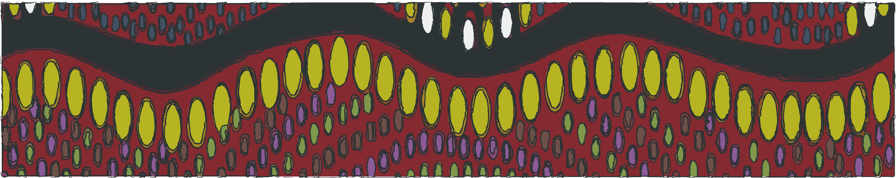

2019 NAIDOC WEEK INDIGENOUS ART EXHIBITION

July 5th – July 28th

Entries are now open for the
Bass Coast/South Gippsland Reconciliation Group 2019 NAIDOC Week Indigenous Art Exhibition

This year the exhibition will be held over the same dates at two different venues:

Stockyard Gallery Foster and Inverloch Community Hub

We invite any Gippsland indigenous artist to submit their works for exhibition to either of the shows. Please find attached the entry form for the 2019 exhibition. Completed forms can be submitted to Mary Sullivan –
mary.sullivan@southgippsland.vic.gov.au

KEY DATES:
24th June - Entries close, all works to be dropped off at South Gippsland Shire reception,
9 Smith Street Leongatha by today (9-5pm)
4th July - Stockyard gallery exhibition opens
5th July - The Inverloch Hub exhibition opens
28th July - both shows close
31st July – all works to be collected from South Gippsland Shire reception,
9 Smith Street Leongatha today (9-5pm)

For further information please contact:
Barbara Look (South Gippsland Shire Council)
barbaral@southgippsland.vic.gov.au / 56629319

Mary Mutsaers (Bass Coast/South Gippsland Reconciliation Group)
maryemutsaers@gmail.com / 0478255803

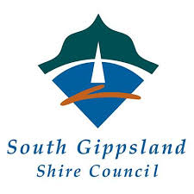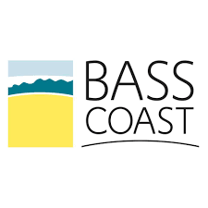

Bass Coast/South Gippsland Reconciliation Group
2019 NAIDOC WEEK INDIGENOUS ART EXHIBITION

ENTRY FORM
your details:

NAME

POSTAL ADDRESS

EMAIL

PHONE

ABN (if currently registered for GST)

artwork:

TITLE | MEDIUM | PRICE
1.

2.

3.

4.

5.

6.

7.

8.

your bank details:

BSB #

ACCOUNT #

ACCOUNT NAME

Bass Coast/South Gippsland Reconciliation Group
2019 NAIDOC WEEK INDIGENOUS ART EXHIBITION
CONDITIONS OF ENTRY
Entries must be the original work of the artist.
The number of entries should not exceed six.
Entries are to be properly labelled with; the name of the artist, title of the work, medium, and price. Entries to be securely prepared for hanging using flush ‘D’ rings and wire as shown in the example. Please do not use string; cord attached with staples or any protruding screw eyes.
Artists are requested to provide a personal profile / CV for publicity, and potential buyers.
Artist are requested to state whether or not their works are for sale. Stockyard Gallery will manage all purchases that take place at the Stockyard Gallery and Mary Mutsaers will manage all purchases that take place at the Inverloch Community Hub. Neither South Gippsland Shire Council nor Bass Coast Shire Council will have any role in managing the sale of works or the transferal of payments.
The committee will have the right to photograph work for any promotional purposes including a catalogue.
All entries will be considered for hanging; however, the committee reserves the right not to hang any work that does not comply with Reconciliation Australia’s vision and mission to promote respect and trust between the wider Australian community and Aboriginal and Torres Strait Islander peoples.
The committee will exercise all reasonable care with submitted works, but will not be responsible for loss or damage to any work while in its custody, or for insurance on works.
Paintings exhibited in a previous Bass Coast / South Gippsland Reconciliation Group NAIDOC Week Indigenous Art Exhibition are not eligible to be hung in the 2019 exhibition.
FEES AND PAYMENTS
Entry is free.
No commission is charged.
All payments to the artists will be by direct transfer to their nominated account.
DELIVERY OF ART WORKS : 24th June
Location: South Gippsland Shire Council reception, 9 Smith Street, Leongatha

