Planning and Environment Act 1987

SOUTH GIPPSLAND PLANNING SCHEME

AMENDMENT C65

EXPLANATORY REPORT

Who is the planning authority?
This Amendment has been prepared by the South Gippsland Shire Council which is the planning authority for this Amendment.
The Amendment has been made at the request of Mr Geoff Murphy acting for Mrs S Murphy (landowner).

Land affected by the Amendment
The Amendment applies to land identified in the Planning Scheme as ‘Urban Expansion Area’, being 77 Gibson Street which is comprised of these lots;
- Part L2 PS330446R (Vol. 10177, Folio 077, approx. 17.2ha),
- L1 PS330446R (Vol. 10177, Folio 076, 0.8ha),
- L2 PS404151C (Vol. 10381, Folio 344, 28.3ha) and
- L1 PS404151C (Vol. 10381, Folio 343, 12ha).
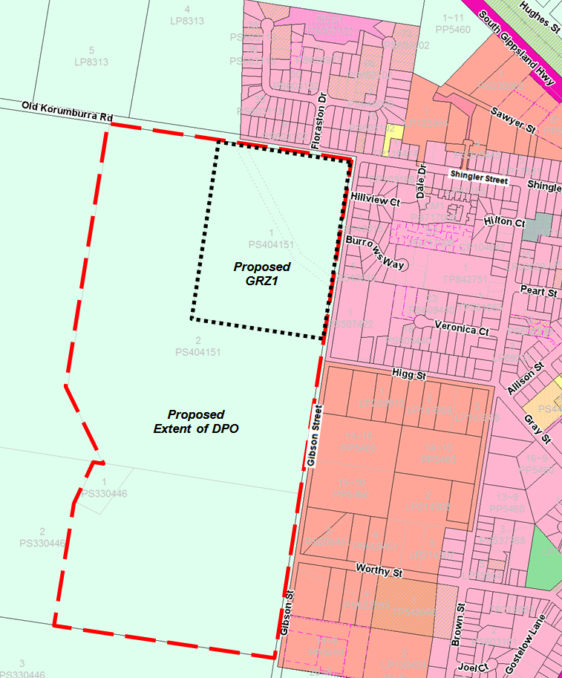

The site outline (right) shows the
proposed rezoning (black dotted
area) and DPO extent (red
dashed outline).

What the amendment does
The amendment;
- Rezones part of 77 Gibson Street, (L1 PS404151C (Vol. 10381, Folio 343, approx. 12ha) from Farming Zone to General Residential Zone.
- Applies a Development Plan Overlay (DPO) to 77 Gibson Street, specifically, lots;
- L1 PS404151C (Vol. 10381, Folio 343, 12ha)
- L2 PS404151C (Vol. 10381, Folio 344, 28.3ha)
- L1 PS330446R (Vol. 10177, Folio 076, 0.8ha),
- Part L2 PS330446R (Vol. 10177, Folio 077, approx. 17.2ha),
- Remove Environmental Significance Overlay 5 (Erosion) from the proposed DPO area and
- Remove Environmental Significance Overlay 6 (Flooding) from the proposed DPO area

Strategic assessment of the Amendment

Why is the Amendment required?
An amendment is required to change the zone of the subject land and apply a DPO to lots identified in the Planning Scheme as Urban Expansion Area. These changes will allow residential development of the site.

How does the Amendment implement the objectives of planning in Victoria?

The amendment implements the objectives for planning in Victoria set out at Section 4 (1) of the Planning and Environment Act 1987.The amendment provides for fair, orderly, economic, sustainable use and development of land by promoting township development in a strategically planned, long term manner. The subject land lies within the existing township boundary and the proposed rezoning will facilitate orderly expansion of Leongatha consistent with the Leongatha Town Structure Plan and Clause 21.15 ‘Local Areas’ of the South Gippsland Planning Scheme.

The amendment provides for the protection of natural and man-made resources and the maintenance of ecological processes and genetic diversity though applying buffer areas to identified drainage reserves. The buffers protect against the erosive forces of surface water runoff caused by development and protect river systems downstream. The impacts on flora and fauna resulting from township growth identified in the Framework Plan is expected to be minimal.

The amendment will “secure a pleasant, efficient and safe working, living and recreational environment for all Victorians and visitors to Victoria”. This will be achieved through the development of liveable townships with strong pedestrian and cycle connectivity and recreational spaces for community enjoyment. The provisions aim to provide for highly liveable communities in a sustainable manner.

How does the Amendment address any environmental, social and economic effects?
Environmental Effects
The amendment will not have any adverse environmental effects because of the required responses of surface water drainage through a development buffer area and drainage reserve to protect against erosion.
Development in accordance with the township plans is unlikely to have a detrimental impact on the environmental qualities of the subject townships and their immediate surrounding environments. The specific ‘Objectives and Strategies’ of the township provisions encourage development that has close regard to the environmental values of the subject and surrounding lands.
The removal of the Environmental Significance Overlay 5 (Erosion) and 6 (Flooding) will not have an effect as these overlays were applied as a broad approach to protection without consideration to specific areas. Investigation has shown that removal of these overlays will not have a significant effect on the environmental values of the land.
Social and Economic Effects
The amendment will not have any adverse social or economic effects. The rezoning will increase the housing choice in Leongatha and provide for residential lots in close proximity to the town centre. It will be connected to the existing pedestrian networks. The proposal represents a net benefit for local business and support for local community organisations.
The Amendment seeks to create liveable townships which promote vibrant, engaged communities. The Amendment identifies land with significant potential for residential use that will have a use value greater than its current Farming Zone classification.
While the planning scheme encourages the retention of rural land for productive agriculture, the consolidation of residential development at a range of densities, around existing townships is an appropriate means by which to reduce the pressure for ad hoc low density and rural residential development across the Shire’s State significant agricultural areas. The potential loss of agricultural land to residential development must be balanced against the economic gains to the region that will result from encouraging population growth in a planned manner, in the townships. By carefully planning the release of greenfield agricultural land for residential development, the detrimental impacts resulting from the loss of agricultural land can be managed and balanced against the benefits of providing additional residential development opportunities.

Does the Amendment address relevant bushfire risk?
The townships and their immediate surrounds are unaffected by the Bushfire Management Overlay. The site is largely altered pasture land and not considered a high fire risk. The proposed use of the land for high density residential purposes provides the opportunity for bushfire risk to be considered in detail at subdivision.

Does the Amendment comply with the requirements of any Minister’s Direction applicable to the Amendment?
The Amendment is consistent with the Ministerial Direction on the Form and Content of Planning Schemes under section 7(5) of the Act and Ministerial Direction No. 11 Strategic Assessment Guidelines. Directions regarding amendments to planning schemes have been considered in this Explanatory Report.

How does the Amendment support or implement the State Planning Policy Framework and any adopted State policy?
Proposed amendments directly support an implementation of the State Planning Policy Framework (SPPF) through the following:
Clause 11 Settlement
The proposed rezoning is a response by Council to the needs of existing and future communities. The proposed rezoning provides appropriately zoned and serviced land for housing. It will also generate direct and indirect employment opportunities during development, and will enhance the recreation and open space facilities, facilitate the provision of commercial and community facilities and necessary infrastructure for future communities.
Clause 15 Built Environment and Heritage
The proposed rezoning and the provisions of the DPO respond to the need for appropriate building and design during urban expansion. The construction guidance provided by the DPO supplies and maintains adequate and safe physical and social environments for residents. This is an appropriate location for the proposed uses and development.
Clause 16 Housing : Subclause 16.1 Residential Development
The siting, design guidelines and local policy control addresses the provisions of this clause and responds suitably to the requirements for;
- Integrated Housing,
- Location of residential development,
- Strategic development sites,
- Housing diversity, and;
- Housing affordability
Clause 18 Transport : Subclause 18.02 Movement Networks
The DPO ensures that the connectivity to activity centres is provided for new residents. New paths connect to the town activity areas by the shortest route practicable.

How does the Amendment support or implement the Local Planning Policy Framework, and specifically the Municipal Strategic Statement?
Clause 21.05 Settlement
The proposal is consistent with the identified growth role for Leongatha as the principal township in the shire.
21.09 Built Environment and Heritage: Subclause 21.09-2 Urban environment
The proposed development recognises its location context through the DPO, improving the urban environment by balancing the needs of urban growth and the rural sense of place.
21.10 Housing
The provision of more land for residential development increases the housing stock diversity within the town. It ensures that development is planned and avoids eroding the remaining productive agricultural land.
21.15 Local Areas: Subclause 21.15-1 Leongatha
The rezoning and extent of the DPO applies to land identified for urban expansion in the Leongatha Framework Plan. This identifies the potential for future growth and ensures a sequential development pattern which integrates with existing residential areas. Applying the DPO to the wider land area shows an intent to consider future development by coordinating a ‘whole of site approach’.

Does the Amendment make proper use of the Victoria Planning Provisions?
The proper use of the provision is achieved by allowing for the land identified in the Planning Scheme to be rezoned appropriately to General Residential Zone.
The Amendment also proposes to use the Development Plan Overlay outlining the requirement for the orderly outcomes of future developments.

How does the Amendment address the views of any relevant agency?
The views of planning scheme referral authorities and other agencies were considered in the development of the township structure plan which forms the basis of the Amendment provisions. Notice of the Amendment will be provided to the authorities and agencies that have an interest in the development of the townships.

Does the Amendment address relevant requirements of the Transport Integration Act 2010?
The Amendment provisions identify land that is suitable for township expansion and rezones land within the township. This does not constitute “a significant impact on the transport system”.

Resource and administrative costs

What impact will the new planning provisions have on the resource and administrative costs of the responsible authority?
The Amendment applies the strategic justification for township expansion in accordance with the MSS township provisions. This will assist Council and private landowners in facilitating the development of land and lessen the resource and administrative costs to all parties involved in facilitating development.
Township growth will have implications for Council’s capital works budgets. These implications are to be closely considered before greenfield land is developed. Appropriate development contributions will be required to support new development.

Where you may inspect this Amendment
The Amendment is available for public inspection, free of charge, during office hours at the following places:
South Gippsland Shire Council , 9 Smith Street Leongatha, and Council’s web page www.southgippsland.vic.gov.au .
The Amendment can also be inspected free of charge at the Department of Environment, Land, Water and Planning website at www.dtpli.vic.gov.au/publicinspection .

Submissions
Any person who may be affected by the Amendment may make a submission to the planning authority. Submissions about the Amendment must be received by Monday, 31 August 2015.
A submission must be sent to: South Gippsland Shire Council,
Att Nick Edwards
Private Bag 4, (or 9 Smith Street),
Leongatha, 3953

Panel hearing dates
In accordance with clause 4(2) of Ministerial Direction No.15 the following panel hearing dates have been set for this Amendment:
- directions hearing: week starting 5 October 2015
- panel hearing: week starting 9 November 2015

