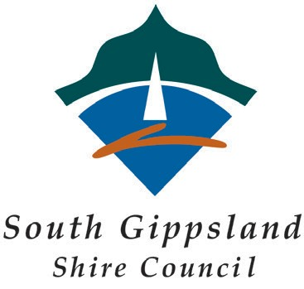

South Gippsland Shire Council
Community Grants Program

Project Management Framework

COMMUNITY GRANTS PROGRAM PROJECT MANAGEMENT FRAMEWORK

Organisation Name: |  | Project Title:

PROJECT TASK  (Examples can be found on following page) | START DATE | END DATE | TASK RESPONSIBILITY | RESPONSIBLE ORGANISATION | TASK COMPLETED (Y/N)
E.g. Purchase Materials | 12/09/2013 | 12/10/2013 | Frank Murray | Wattle Creek Hall Committee | N

