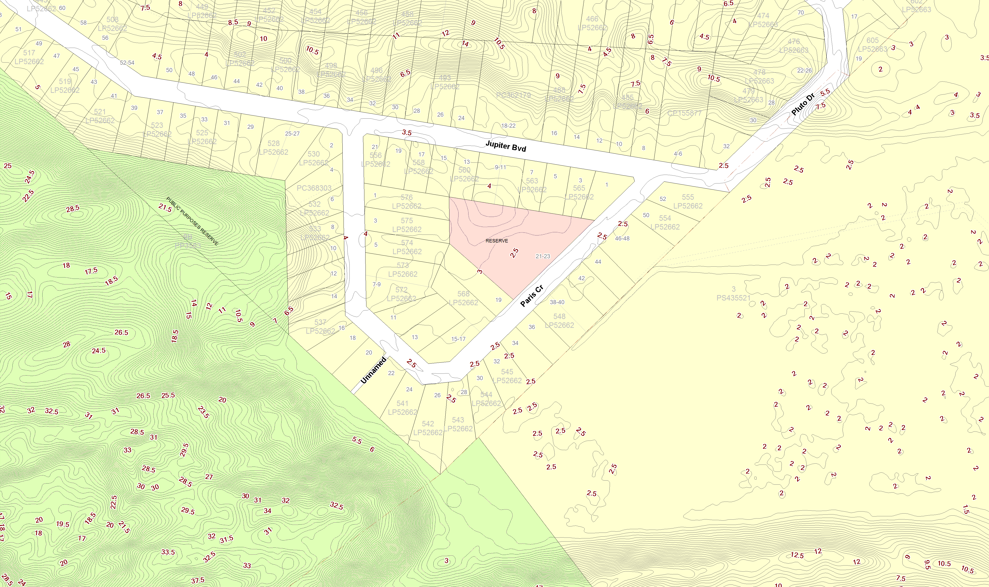
 | Amendment C81 Contour Information (Venus Bay Estate 1) – Land Height Above Sea Level  The red coloured numbers in this map are contour heights displaying the height of land above sea level. For example, Paris Crescent is 2.5m above sea level. The LSIO provisions do not require a planning permit if a dwelling is 3.4m or move above sea level. If your land is already 2.5m above sea level and you want to build a dwelling, the habitable areas of the dwelling would have to be 0.9m above ground level to avoid requiring a planning permit in the LSIO. | Map Zoom: 722.8 m

